 | 12.3.5 Editors - Geometry Nodes Editor - Sidebar - Add
Table of content
Input and Modify Tab - Not yet 1
Usage 1

Add Tab
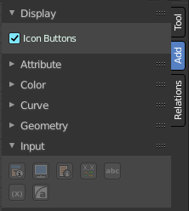
Here you can find the same nodes than in the Add menu. The panel stays open. Which makes the usage of this menu content easier. It's your decision with what system you want to work.
The first panel contains an icon checkbox with which you can toggle between text buttons and icon buttons.
We won't explain the content of the panels again. The single nodes are explained in the add menu chapter.

Usage
Click at one of the node buttons, then move the mouse into the viewport. The created node sticks at the mouse. Click again to release it.

